**Database Foundations for Business Analytics: Upload Assignment - MySQL install**

**-**Likith Vinayaka Giridhar (LXG210034)

1. Screenshots of MySQL server details of Cloud database

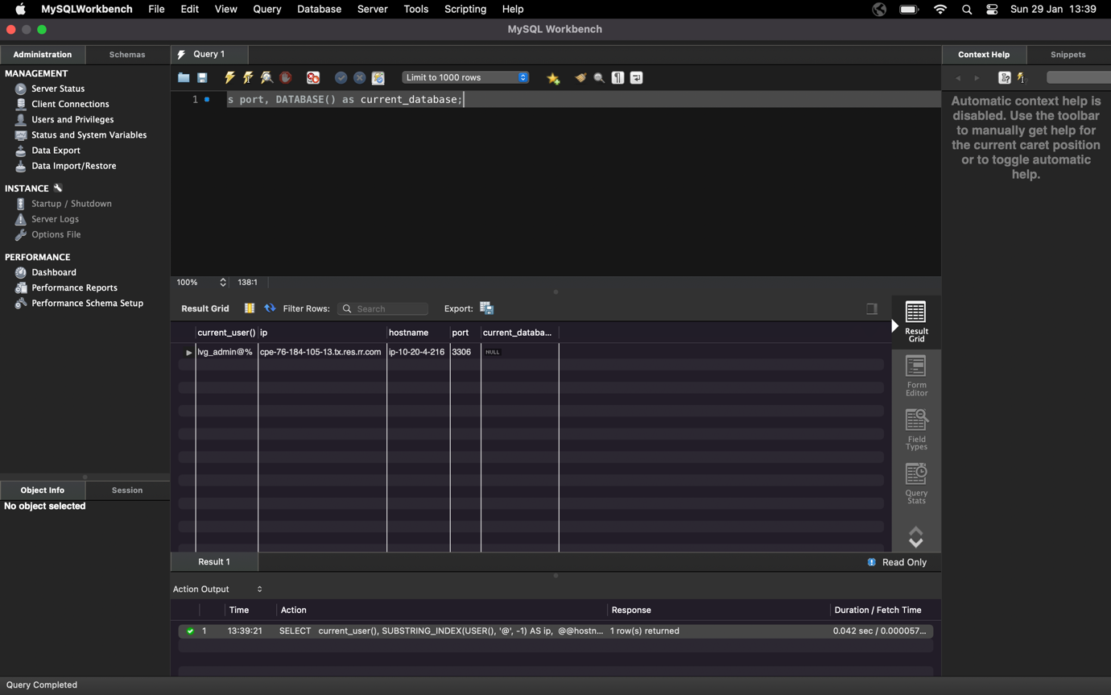

1. Screenshot with laptop name and MySQL server details of Cloud database

